**UNIVERSITY OF MUMBAI**

A PROJECT REPORT ON

**“The Silver Screen APK”**

SUBMITTED BY

**Patel Arun Ramjanak**

Under the guidance of

**Prof.** **Pradnya Mhatre**

**Late Shri. Vishnu Waman Thakur Charitable Trust’s**

**VIVA INSTITUTE OF TECHNOLOGY**

**Shirgaon, Virar(East)**

**2021-2022**

**Late Shri. Vishnu Waman Thakur Charitable Trust’s**

**VIVA INSTITUTE OF TECHNOLOGY**

**Shirgaon, Virar(East)**



**CERTIFICATE**

**This is to certify that**

**Mr. Patel Arun Ramjanak**

**Has satisfactorily completed the project entitled**

**The Silver Screen APK**

**Towards the partial fulfillment of the**

**MASTER OF COMPUTER APPLICATION (MCA)**

**As laid by University of Mumbai.**

____________ ____________________ ________________

**Principal External Examiner Internal Guide**

**Declaration**

We hereby declare that we have completed the project under the guidance of **Prof**. **Pradnya Mhatre**. We have designed the system and have done all the programming required.

It may require some modifications in the future as per the user’s requirements. From practical implementation point of view, flexibility in the changes have incorporated in the package.

We assure that we can do any kind of modification suggested while practical implementation by modifying file design or the program code if necessary.

**Acknowledgement**

First and foremost. we bow our head to the Almighty for being our light and His showers of blessing during this mini project. I extend our gratitude to **Dr. ARUN KUMAR**, Principal. Viva Institute of Technology, to provide all the resources to do this mini project work. we record our sincere thanks and respect to our Head of Department, Prof. Chandani Patel, Department of Master of Computer Application, Viva Institute of Technology, with her good attention and outstanding guidance in all the work of our project.

We are indebted to our project coordinator and project guide **Prof. Pradnya Mhatre**, Department of Master of Computer Application, Viva Institute of Technology for her guidance and important suggestions for all the ways to complete our project.

we extend our deepest gratitude to all the other staff for their support and all assistance during the study and course work of the project. Finally, we truly thank our parents and friends for giving us valuable and suggestion for the improvement of our project.

**Abstract**

Today date young generations have lots of free time. They are spending their time watching movies and web series. The Silver Screen is a full-stack project where the backend is written in java and spring. And Frontend is written in React Native. The Silver Screen provides functionality to watch and download movies and web series. We are testing this project using JUint 5 and manual testing. The performance testing is done using JMeter. The project Is Bug-free and working well. We have a plan to improve UI.

In the project, we get all movie details data from the IMDb website. we doing this thing using the JSOUP java library. JSOUP is the powerful java library used to extract data from HTML pages. To help JSOUP we extract relevant information for our project like movie name, movie cast and crew, rating, runtime, movie images etc. And we are getting movie play links from torrent.

**INDEX**

|  |  |  |
| --- | --- | --- |
| **Sr. No.** | **Contents** | **Page No.** |
| 1 | **Introduction**  **1.1 Introduction**  1.1.1 Problem definition  1.1.2 Objectives of Project  1.1.3 Scope of Project  **1.2 Technical Details**  1.2.1 Overview of APK  1.2.2 Overview of Back End |  |
| 2 | **System Study and Planning**  **2.1 System Study**  2.1.1 Existing System  2.1.2 Disadvantages of Existing system  2.1.3 Proposed System  **2.2 System Planning and Schedule**  2.2.1 S/W development Model |  |
| 3 | **System Design**  **3.1 Software Requirement Specification (SRS)**  3.1.1 Introduction of SRS  3.1.2 Technology Requirements  3.1.2.1 Hardware to be used  3.1.2.2 Software/Tools to be used  **3.2 Detailed life Cycle of the Project**  3.2.1 Modules  3.2.2 Object Oriented Analysis & Design Diagrams  3.2.2.1 Use Case Diagram  3.2.2.2 Activity Diagram  3.2.2.3 Class Diagram  3.2.2.4 Sequence Diagram  3.2.2.5 Flowchart/DFD/ER diagram  3.2.3 Database  3.2.3.1 Database Table  3.2.4 I/O Screen Layout |  |
| 4 | **Testing** (Any Model explanation in terms of your project)  4.1 Methodologies used for testing  4.2 Types of Testing (Whichever Used) |  |
| 5 | **Conclusion** |  |
| 6 | **Limitations** |  |
| 7 | **Future Enchantments** |  |
| 8 | **References** |  |

**Introduction**

The purpose of this document is to present an overall description and listing of the functionality of The Testing Assistant for Regression Testing. It will explain the scope of the project as well as describe the system environment. This document will also include an easily traceable means by which the user can trace each functionality’s brief description to its full description. Also included is a user interface specification whereby the user can demonstrate interface standards to be used in designing the system. Furthermore, considerations regarding non-functional requirements and system evolution are addressed.

This document is intended for users of the system including Unit Testers, unit test supervisors, and any individuals involved in testing a new system in development. This document will also be used as a reference for the developers of The Testing Assistant for Regression Testing

Today date people love to watch movies online. The Silver Screen APK is a project where people will be watched their favorite movie without any advertisement and without spending their money. The Silver Screen APK gets all movie details from IMDb and movie play links from Torrent-Z. We also stored some good movies in the database. People will search their favorite movie by name and also search by their favorite category like crime, superhero, sports, etc. And watch that movie different quality. It totally depends on the user. The Silver Screen APK user interface is very simple that way user easily play their movie.

**Problem definition And Objectives of Project**

In today's world, after increasing COVID case, cinema halls are closed and people are staying home. people have lots of free time. that time they spend playing games and watching movies and web series. according to Netflix after the first lockdown heavy traffic increased on their website. people are taking more online subscriptions and spending money but those who don't have money don't take this subscription. That's why we creating this website. this website is free available movies and web series. then people don't come outside of their home and they are safe and another one also safe.

**Scope of Project**

In our project, we can search any movie by name, category. In Our Project, we will provide full movie details of any movie and we can play any type of movie. Admin can be stored, update and delete movie form database.

**Overview Of APK**

We are using React Native and java-script on the APK. React Native is an open-source UI software framework created by Meta Platforms, Inc. It is used to develop applications for Android, Android TV, iOS, macOS, tvOS, Web, Windows and UWP by enabling developers to use the React framework along with native platform capabilities. That is the reason we are using React Native in the APK. we also use bootstrap and font-awesome in the APK for creating beautiful UI. We are using a third-party video player Java-Script library to play the movie. In APK, we call Backend API and display the movie's details.

**Overview of Backend**

We have been writing the backend in Java using spring boot. spring-boot is used to create fast applications on the backend side. On the backend, we Used the Spring framework. Spring framework is the most popular java framework. In spring framework development is very easy that is the reason we used spring and java in the backend. On the backend side, we create many APIs some are public and some are secured. Secured API only admin can be used. we are using PostgreSQL in the database. we are using spring security and JWT for security. JPA is used to perform database operations. we are also using the JSOUP library for fetching data in IMDB and torrent links.

**Existing System**

There are many existing systems like Netflix, Amazon, Hotstar, and other third-party websites like Katmoviehd, TheMoviesFlix.

**Disadvantages of Existing system**

The Existing system like Netflix, Amazon, and Hotstar are charge prices monthly and yearly basis and other third-party websites like KatmovieHd and TheMoviesFlix are contained lots of advertisements.

**Proposed System**

In this project, we are providing movie details and a movie playing system. our project does not charge any prices to play movies. we also did not add any type of advertisement and our system is very clean. That's why it is very easy to use.

**Software Development Model :- The Agile Modeling**

The rest of the SDLC models we’ve chosen fall under the umbrella of Agile. Nowadays, more than 70% of organizations employ this or that Agile approach in their IT projects. In general, at the heart of Agile are iterative development, intensive communication, and early customer feedback.

Each Agile iteration usually takes several weeks and delivers a complete working software version. The models of this group put more focus on delivering a functioning part of the application quickly. They pay less attention to detailed software documentation (detailed requirement specification, detailed architecture description), and more to software testing activities. This fosters quick development but considerably prolongs software transfer to the support team as well as makes its maintenance more complicated as more time is spent to find the problem when there's no detailed software description.

Agile is about working in close collaboration both across the team and with the customers. At the end of each iteration, stakeholders review the development progress and re-evaluate the priority of tasks for the future iteration to increase the return on investment (ROI) and ensure alignment with user needs and business goals.

Accordingly, frequent releases are characteristic to the Agile models. They also allow for continuous software improvement with easy fixes and changes, quick updates, and feature addition, and help to deliver applications that satisfy users’ needs better. However, the lack of detailed planning and openness to changes make it difficult to accurately estimate budget, time and people required for the project.

In the Silver screen, we first developed the small module on the backend side, and then we integrate it on the APK side. After Integration, we test the module and if the system working fine then we take feedback on that system. And then we go on another module that is the reason we used the agile software developer model in our project

**Technology Requirements**

- Client does not need any Technology Requirements to use this project.

- The developer has good knowledge of Java, Spring boot, PostgreSQL, React Native, HTML, CSS, JavaScript.

**Hardware requirement**

we are planning to deploy this project on Heroku. Heroku is a cloud platform where anyone develops their 5 projects for free. After deploying on Heroku no need for hardware anyone can access this project from anywhere in the world just using the internet.

Ram: - 4 GB

Process: - Intel core i3

Hard Drive: - 250 GB

**Software requirement**

IDEs: - Visual Studio (APK), Eclipse (Backend)

Database: - PostgreSQL

Development Tool: - JDK 1.8, Node.js

Programming Language: - Java, JavaScript

Framework: - Spring Framework, React Native

**Model Diagram**

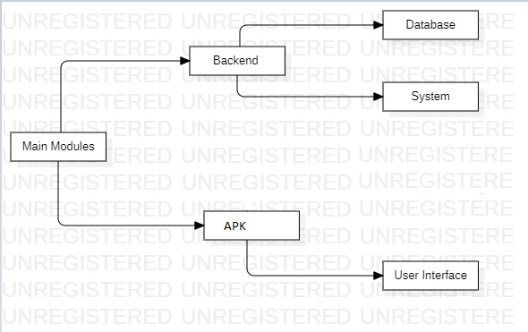

**Use Case Diagram**

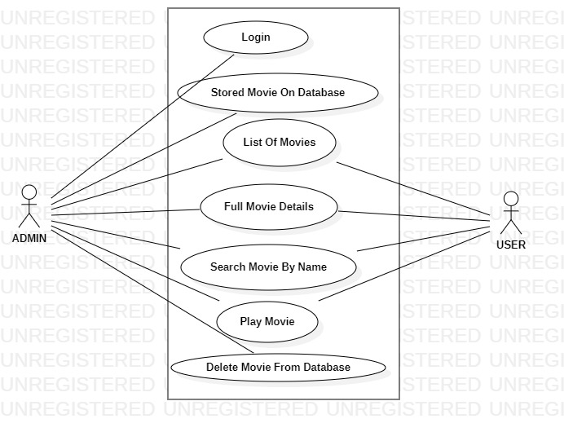

**Activity Diagram**

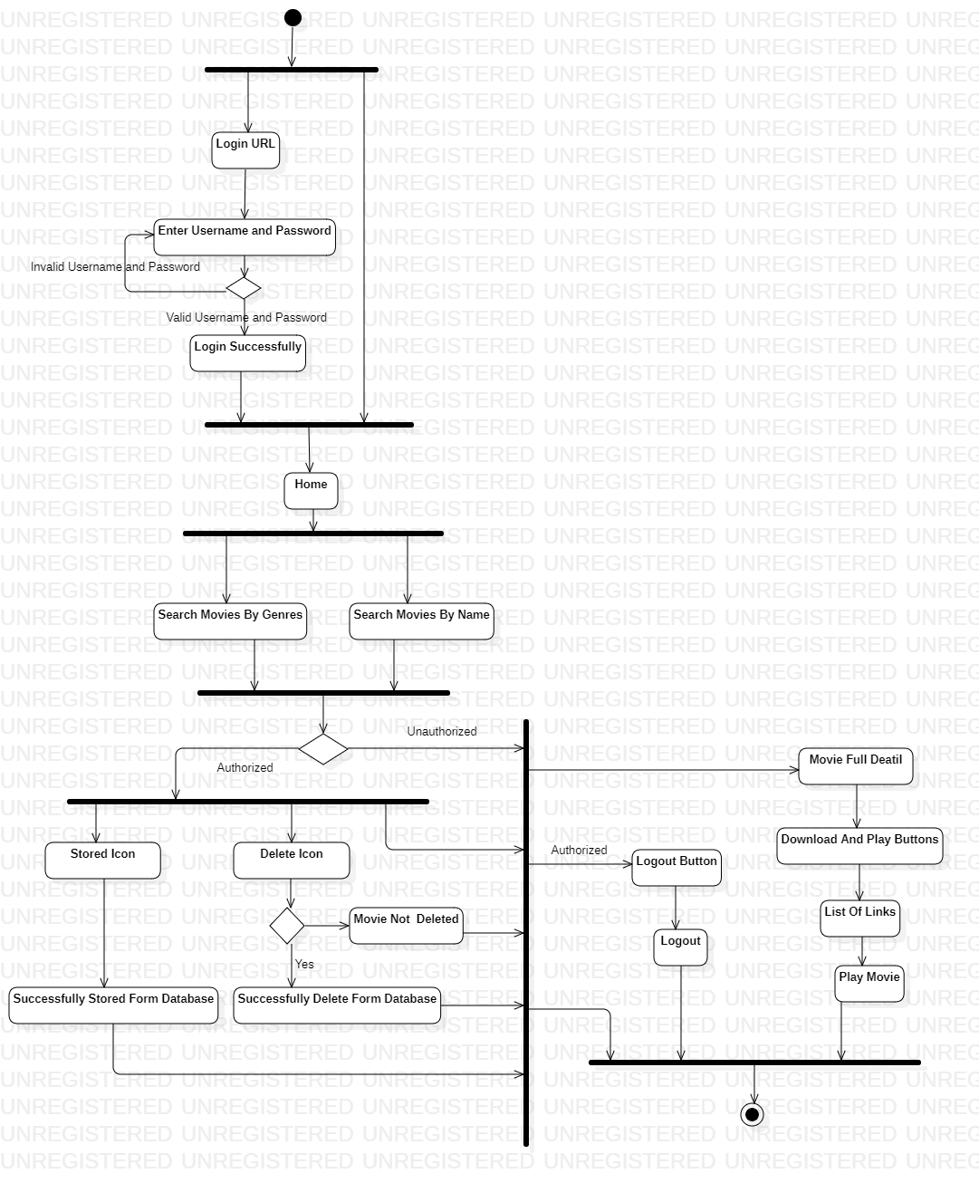

**Class Diagram**

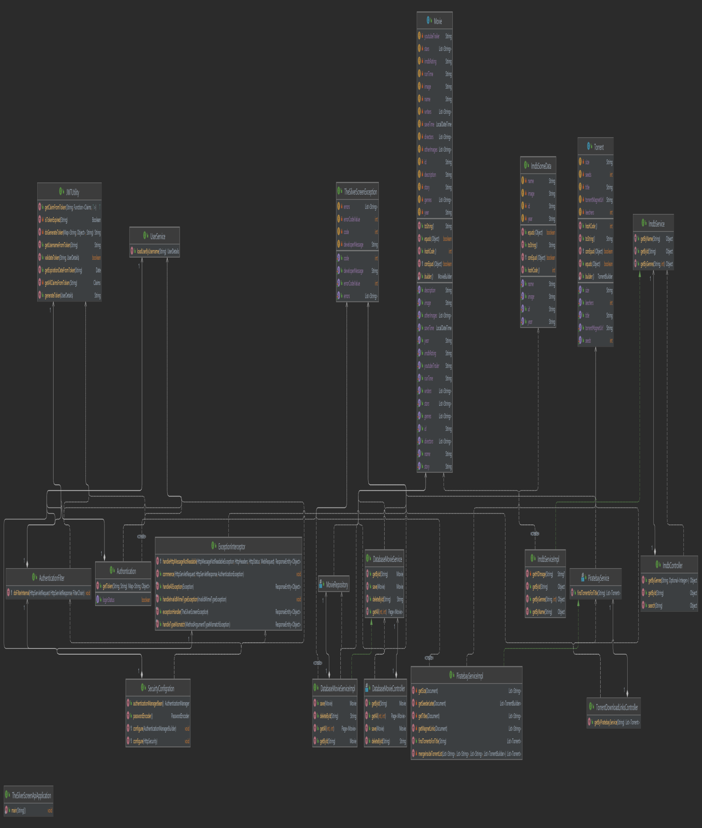

**Sequence Diagram**

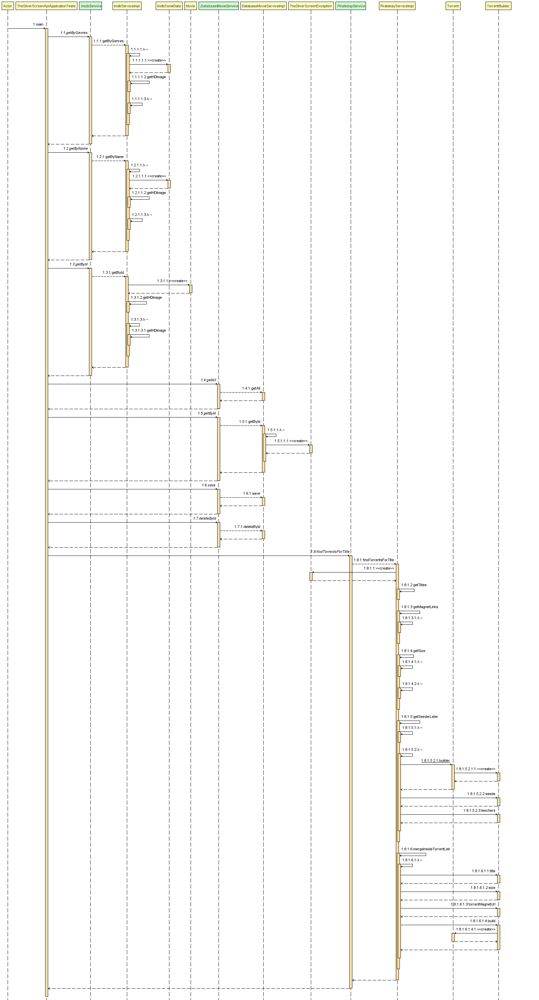

**Database Diagram**

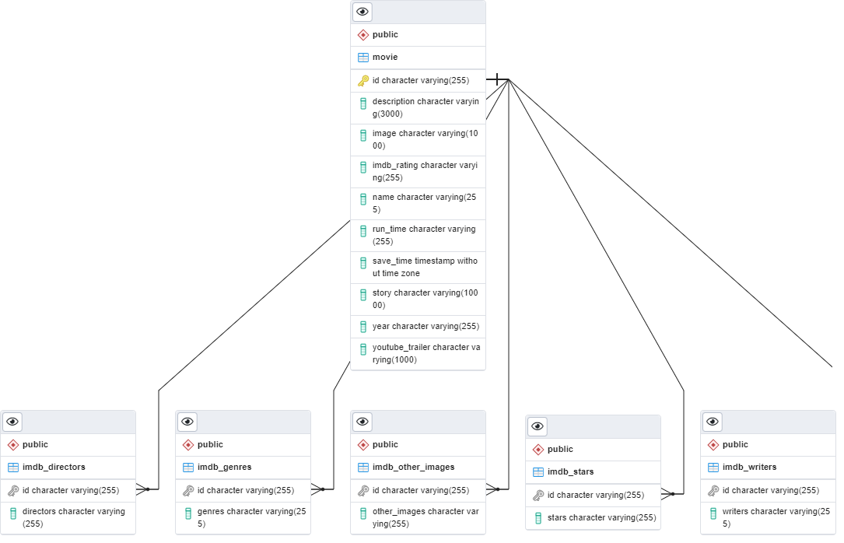

**Interaction Between APK And Backend**

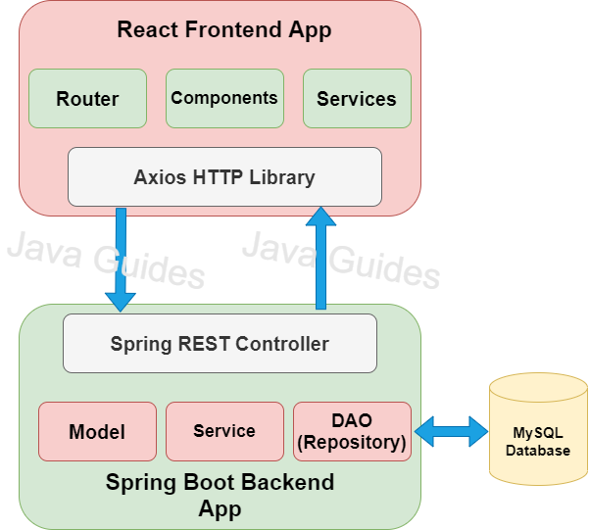

**Movie Table:**



**Movie Writer Table:**

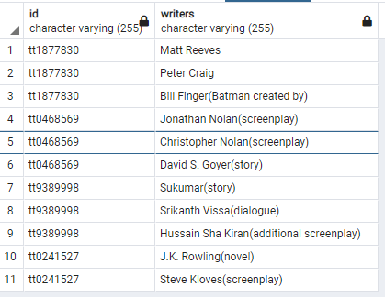

**Movie Star Table:**

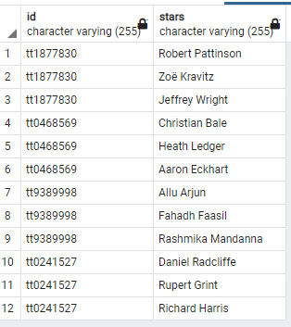

**Movie Other Image Table:**

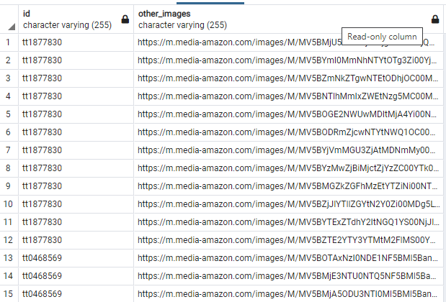

**Movie Genres Table:**

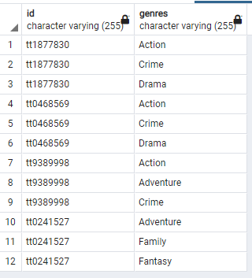

**Movie Directors Table:**

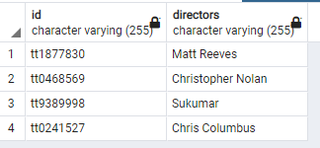

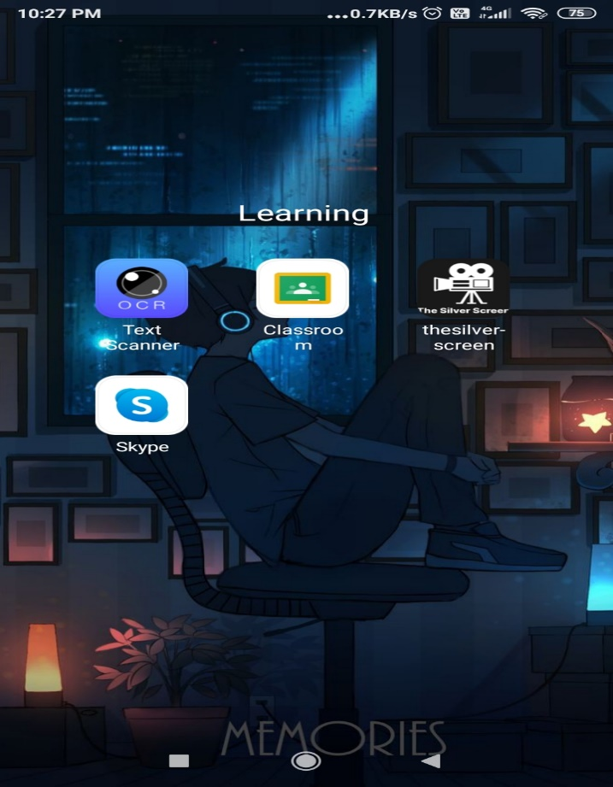 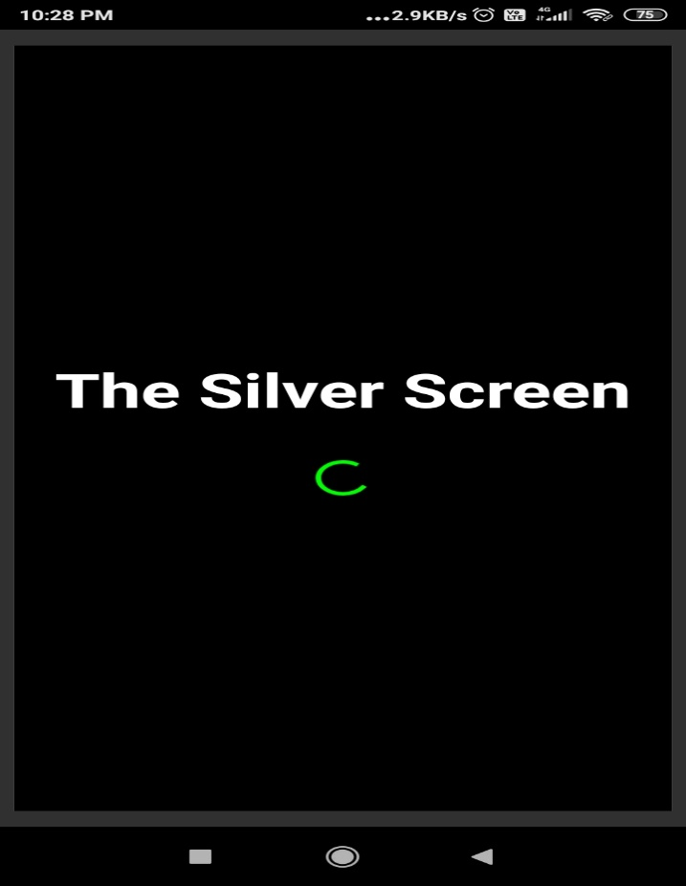

**ICON LOADING PAGE**

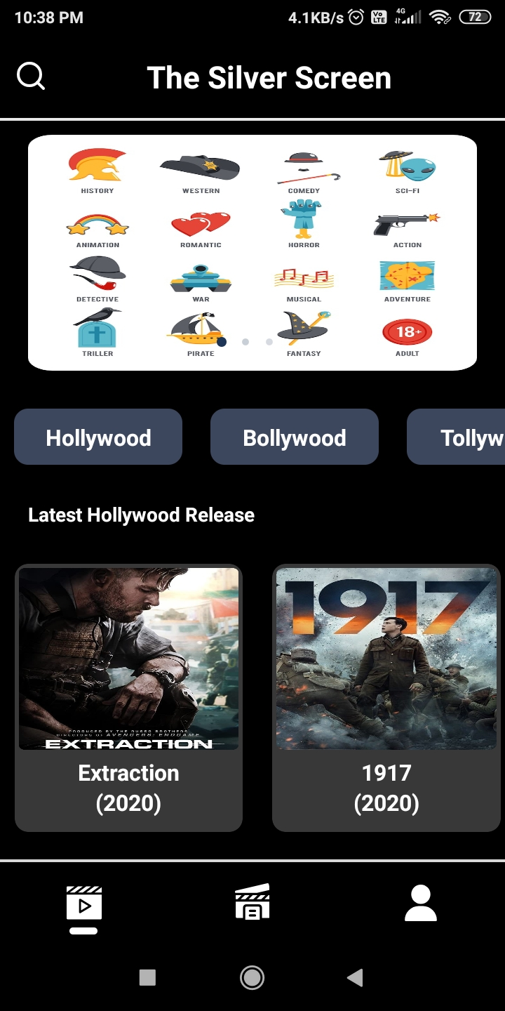 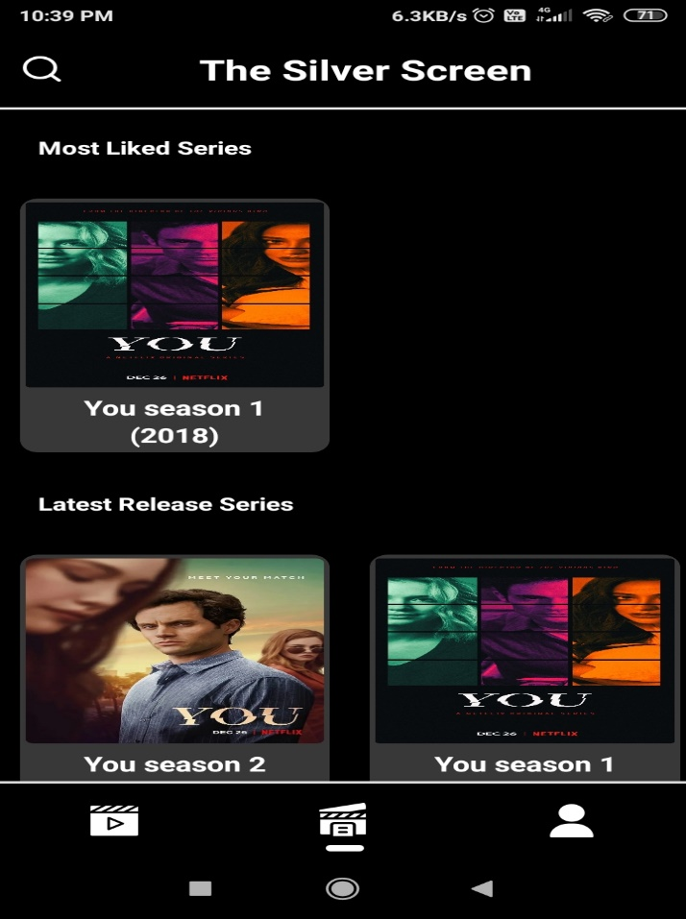

**HOME PAGE SERIES PAGE**

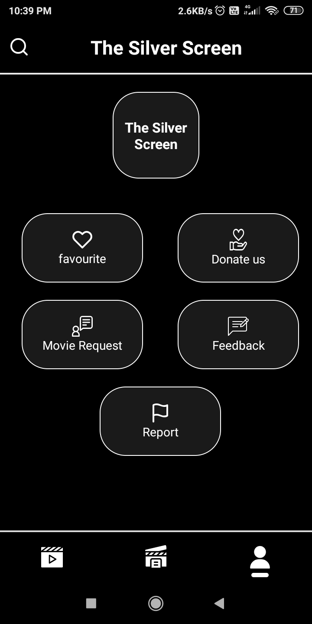 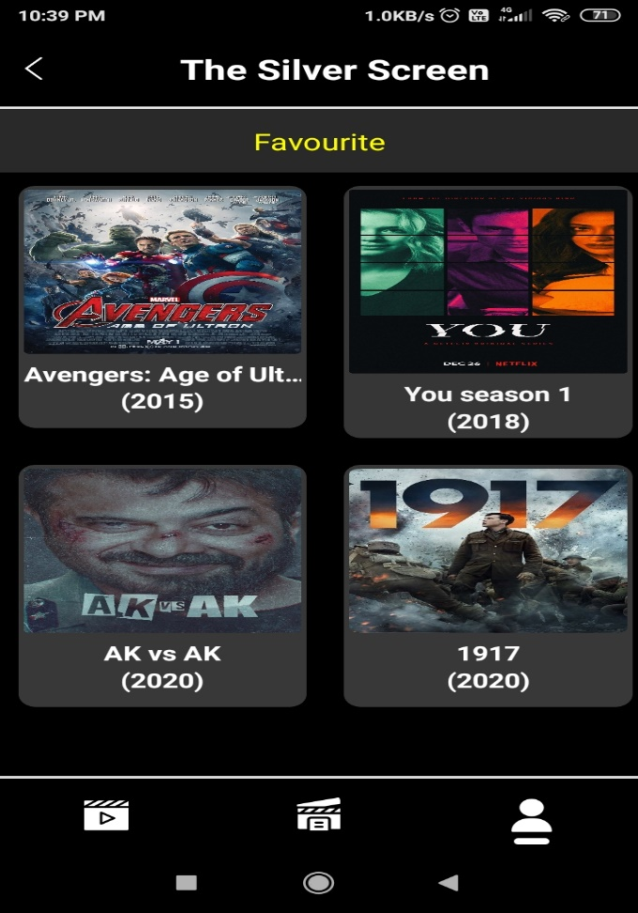

**USER PAGE AFTER CLICKING FAVOURITE ICON**

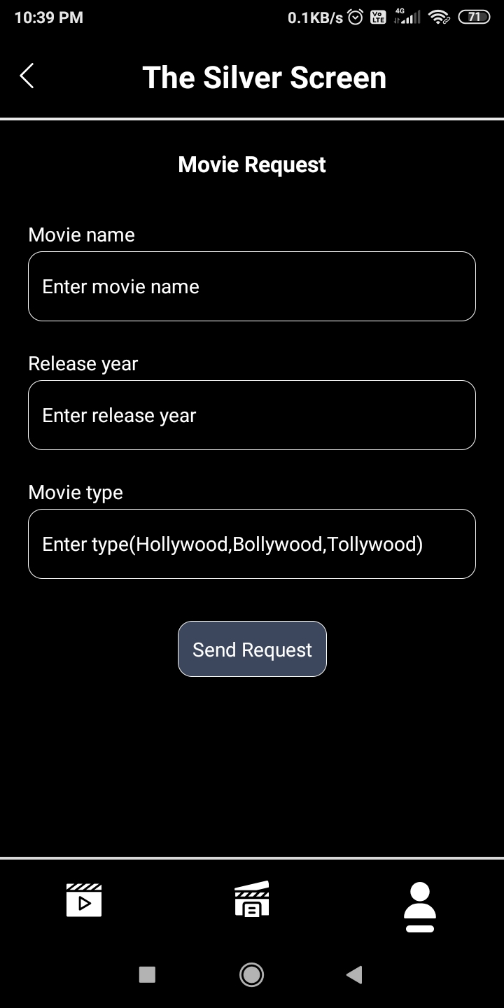 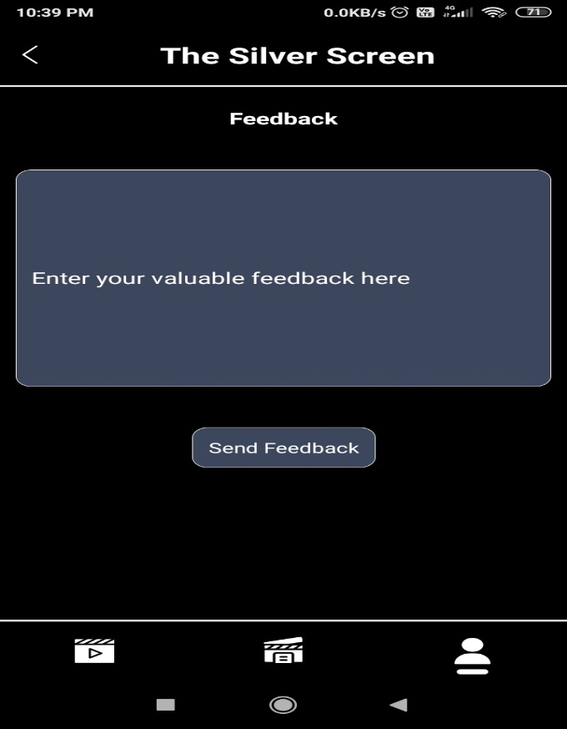

**MOVIE REQUEST PAGE FEEDBACK PAGE**

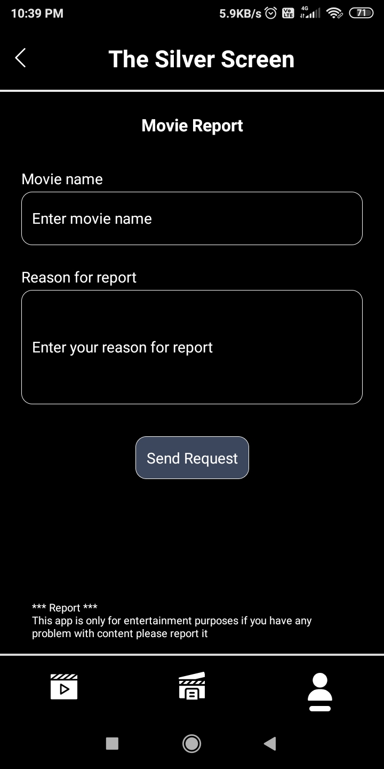 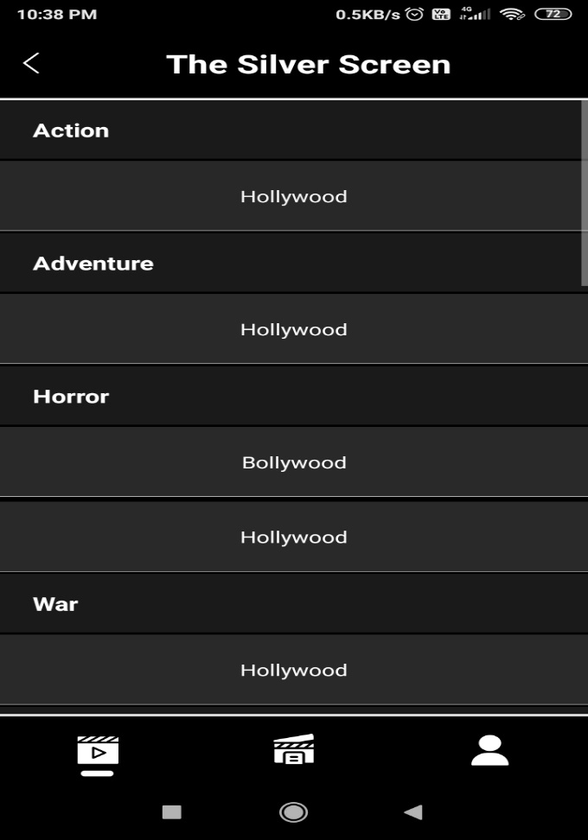

**REPORT PAGE AFTER CLICKING FIRST BANNER**

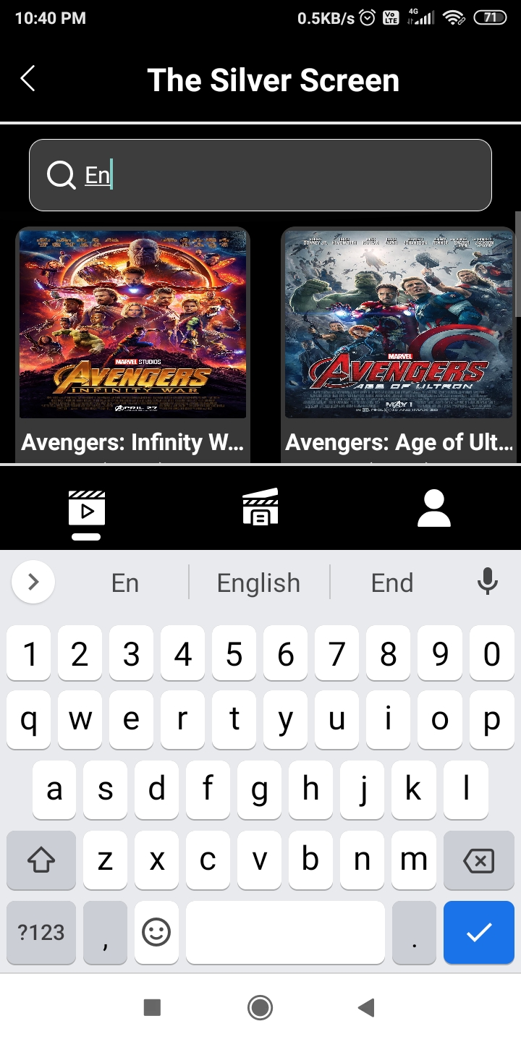 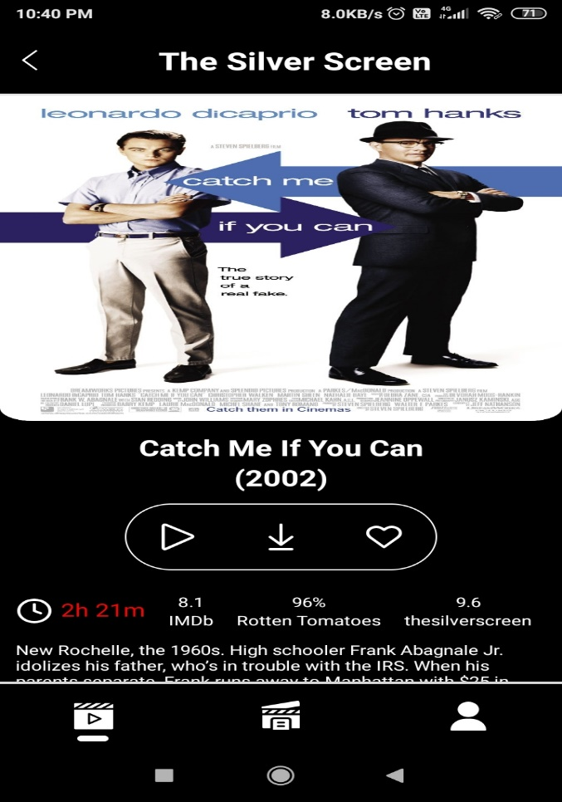

**SEARCH BY NAME FULL MOVIE DETAILS PAGE (1)**

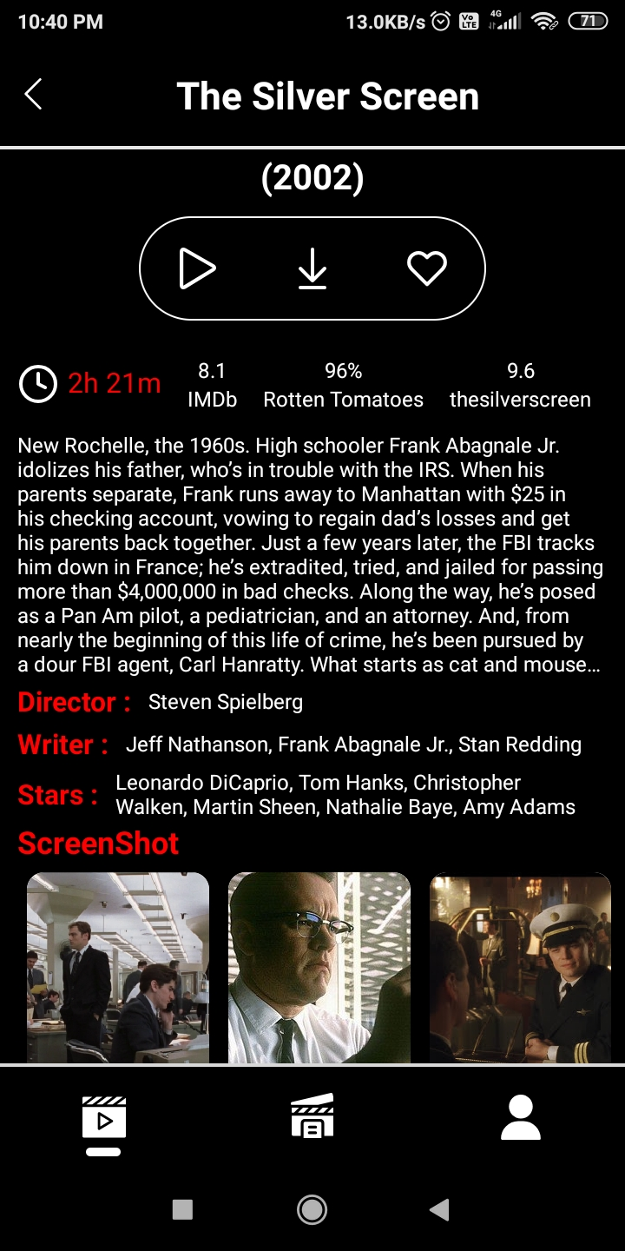 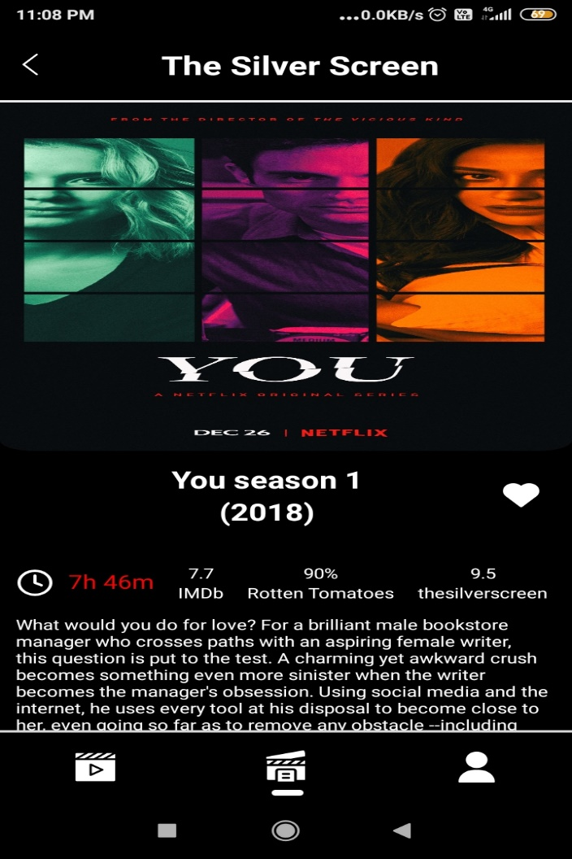

**FULL MOVIE DETAILS PAGE (2) FULL WEB SERIES DETAILS PAGE (1)**

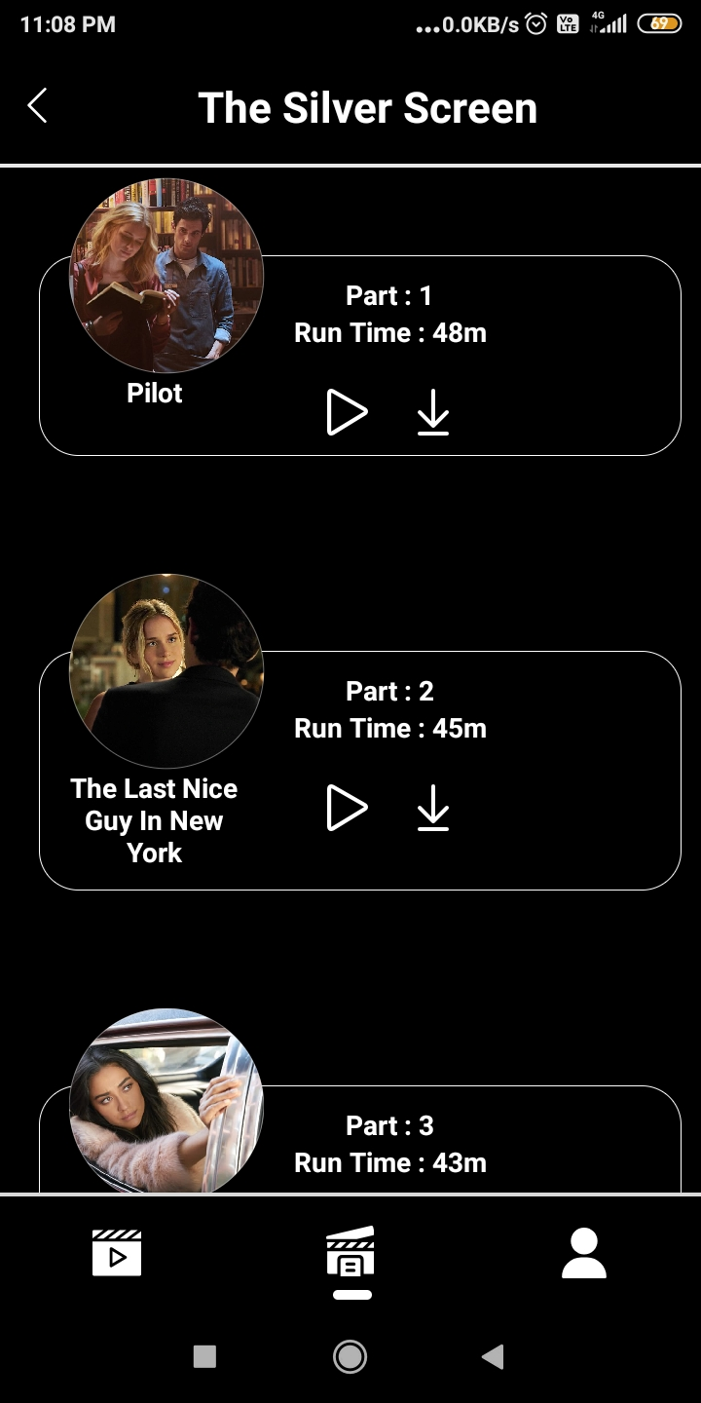 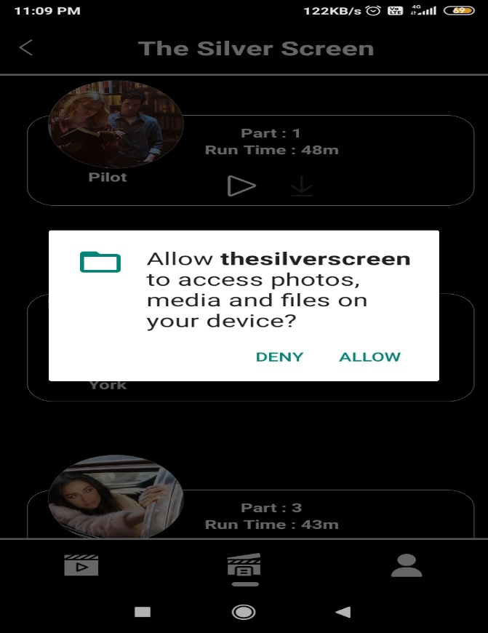

**WEB SERIES PART DETAILS AFTER CLICKING DOWNLOAD ICON**

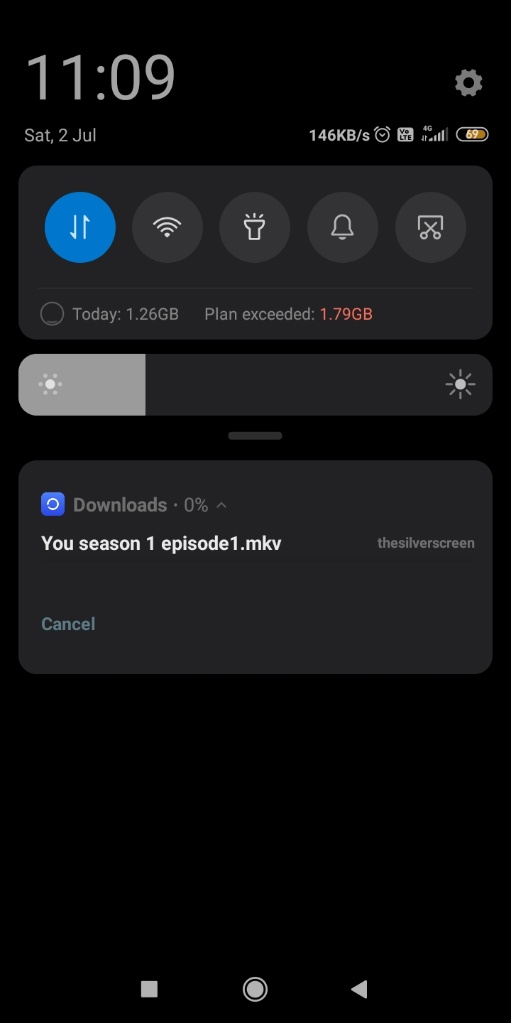

**AFTER ALLOW DOWNLOAD**

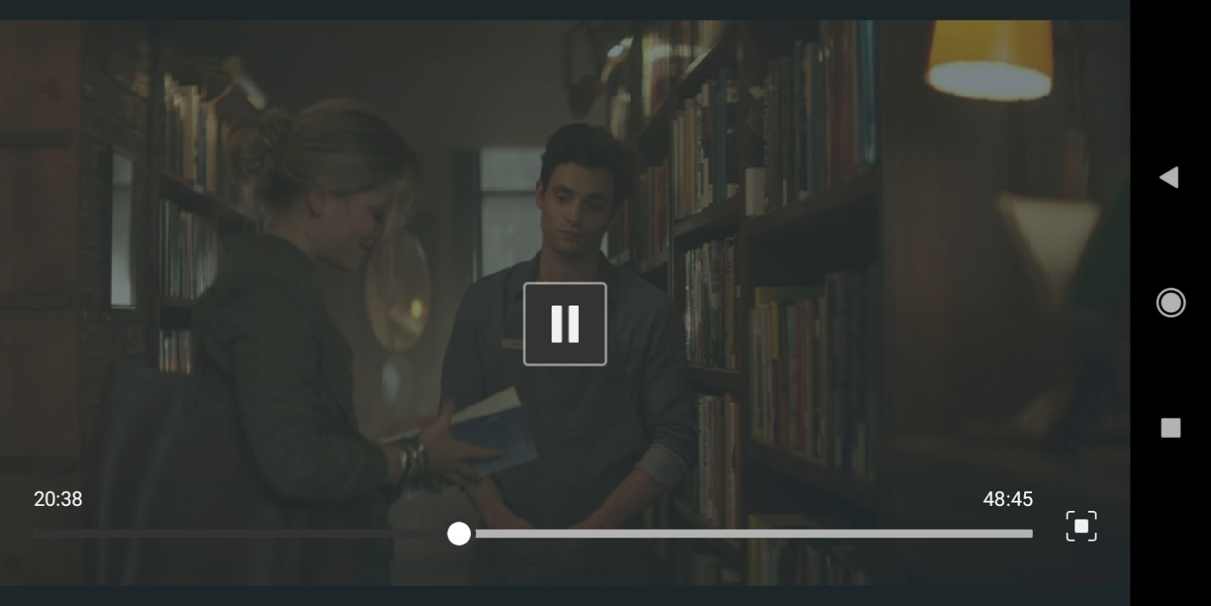

**AFTER CLICKING PLAY BUTTON**

**PROJECT TESTING**

**Software Testing Strategies:**

Testing is a set of activities that can be planned in advanced and conducted systematically. A strategy for software testing must accommodation low-level tests that are necessary to verify that a small source code segment has been correctly implemented as well as high-level tests that validate major system functions against customer requirements

**There are three types of testing Strategies:**

Unit test

Integration test

Performance test

**Unit Testing:**

Unit testing focuses verification efforts on the smallest unit of software design module. The unit test is always white box oriented. The tests that occur as part of unit testing are testing the module interface, examining the local data structures, testing the boundary conditions, execution all the independent paths and testing error-handling paths.

**Integration Testing:**

Integration testing is a systematic technique or construction the program structure while at the same time conducting tests to uncover errors associated with interfacing. Scope of testing summarizes the specific functional, performance, and internal design characteristics that are to be tested. It employs top-down testing and bottom-up testing methods for this case.

**Performance Testing:**

Timing for both read and update transactions should be gathered to determine whether system functions are being performed in an acceptable timeframe.

**Conclusion**

The entire project has been developed and deployed as per the requirements Specification, it is found to be bug-free as per the testing standards that are implemented. Any specification-untraced errors will be concentrated in the coming versions, which are planned to be developed in near future. Its Backend was developed in java, spring boot, and PostgreSQL and we junit5 for testing the backend. And backend is bug-free and completely working fine. The Silver Screen APK developer in React Native and JavaScript. And APK is also bug-free and looking good. The complete system is tested and working well. This design is easy to understand and any new modules can be incorporated easily.

**limitation**

The Silver screen backend gets movies details through IMDb and torrent websites. If this website is down then the backend has some functionality not working properly.

One more limitation of torrent links mainly depends on seeders and lechers means if more people are using the same link for download that time movie will play easily if the link not more people are using that time movie is not play

**Future Enchantments**

Then we can also fix UI for mobile devices. And update their UI. and we will try to provide a more beautiful UI.

And we will also try to update play links. we want to update our video player which is playing movies.

In the future, we will try to find alternatives to torrents. so as to our movie plays easily and people enjoy their movie.

**References**

https://spring.io/projects/spring-boot

<https://reactnative.dev/>

https://jsoup.org/

https://webtor.io/#/en/